**SDN in Docker**

1. **Objective:**

To integrate openvSwitch & opendaylight into docker for communication between multiple containers.

1. **Technologies:**

Docker

OpenDaylight

OpenvSwitch

1. **Implementation:**
2. **Docker networking with openvSwitch**

Containers in different hosts can communicate with each other. There are two ways to connect containers with open vSwitch.

1. connect default docker0 with ovs bridge
2. connect container with ovs bridge directly through veth pair.

We chose the first way, because it’s easier. For the second way, if don’t use the default docker0 bridge, we will need to do more work to connect containers with ovs.

**Topology:**

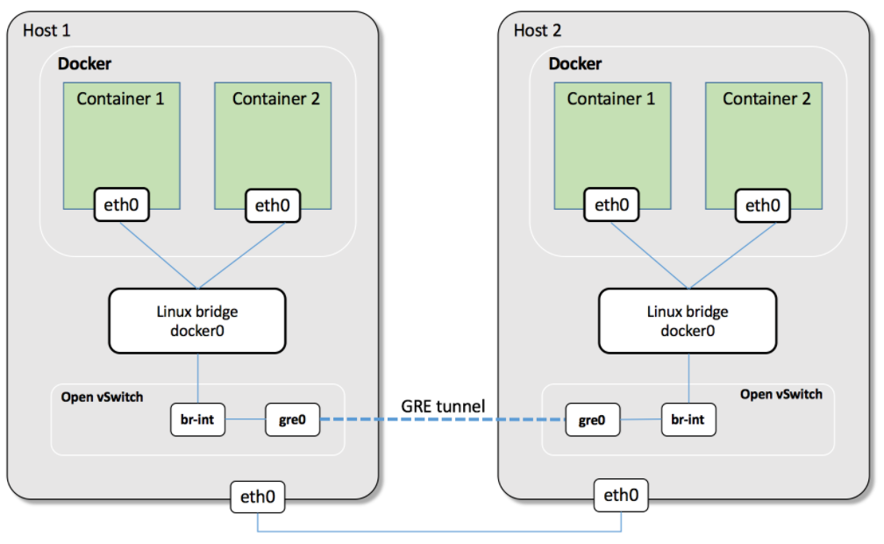

**Step 1: Connect containers with docker0 bridge**

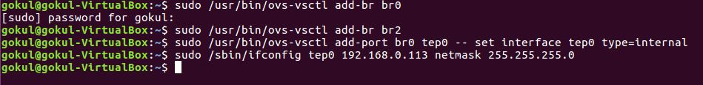

**Step 2: OpenvSwitch configuration**

Install OVS



Host 1:

Create ovs bridge and veth pair and connect veth pair with docker0 and ovs bridge br-int

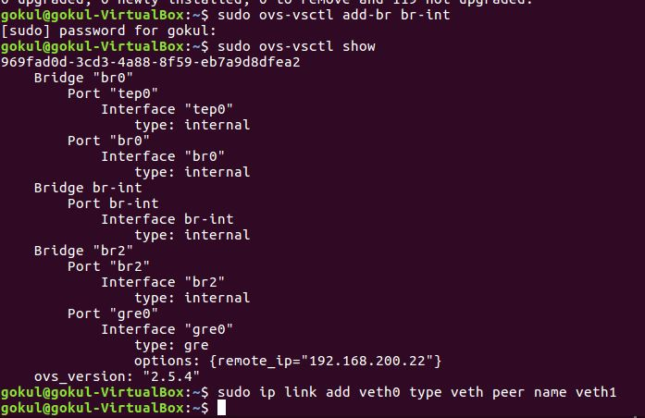

Host 2:

Perform similar steps as in step1.

**Step 3: Gre tunnel between host1 and host2**

The connection between ovs bridge and docker0 bridge

C:\Users\gokul\AppData\Local\Microsoft\Windows\INetCache\Content.Word\Remote Bridge 1.jpg

C:\Users\gokul\AppData\Local\Microsoft\Windows\INetCache\Content.Word\Remote Bridge 2.jpg

**Step 4: Check Tunnel connection**

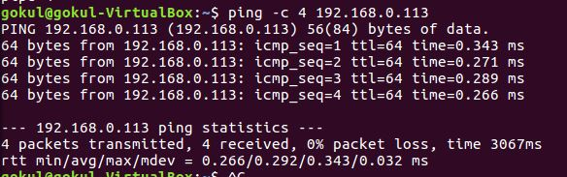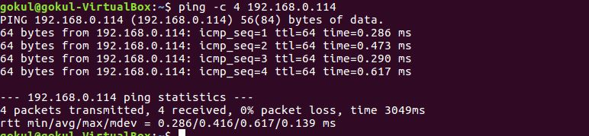

1. **Opendaylight on Docker:**
2. Installation and configuration of docker.
3. Pull default image from public docker registry.
4. Run the docker image.
5. Start karaf console.
6. Install some features of opendaylight to test it.
7. **Challenges faced:**
8. Understanding networking in docker.
9. Installation of opendaylight on docker because of dependency issues.
10. Configuring tunnel connection between two hosts.

**Team:**

Pranita Hatte

Sanjana Hunasamaranahalli Dayananda Kumar

Vaibhavi Vinay Moghe

Gokul Surendra